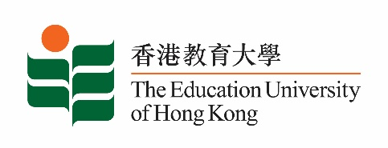
致： 傳媒機構採訪主任 (共 1頁) 10 March 2023
To : News Editors (total: 1 page)

香港教育大學2023年 3月13日至 26日可供採訪之活動一覽
The Education University of Hong Kong (EdUHK) Events Calendar for 13 - 26 March 2023
本校誠邀 貴機構派員採訪下列活動。傳媒查詢，請聯絡教大傳訊處（電話：2948 6050）。
You are cordially invited to cover the events below. For media enquiries, please contact the Communications Office at 2948 6050.

以下活動或有人數限制，傳媒請預先向主辦部門登記。
There may be restrictions on the number of participants for the following event(s). Please contact the respective organiser(s) / department(s) for prior registration.

- 教大大埔校園 （新界大埔露屏路十號） / EdUHK Tai Po Campus (10 Lo Ping Road, Tai Po, New Territories)

日期  Date | 時間  Time | 活動  Event | 地點  Venue | 主辦部門及公眾查詢  Organiser &  Public Enquiry | 備註  Remarks
2023-03-15 | 4 pm – 6:30 pm | 如何把同學們從元宇宙帶回地球？拒絕上學  School refusal - Take our children back from the meta universe to our planet! | 教大大埔校園  D1-LP-03  D1-LP-03,  EdUHK Tai Po Campus | 主辦部門 / Organiser:  特殊教育與輔導學系 Department of Special Education & Counselling  查詢 / Enquiries:  Ms Yoyo Ng  電話 / Tel:  2948 8434 | 活動詳情 / Details:  https://www.jcschooldiversity.hk/ls_talk_2023/

